**PRACTICAL NUMBER : 8**

**AIM :** Inheritance and Abstract Classes

Q.1) Write a dart program to show Multilevel Inheritance.

**CODE :**

class Bird {

void fly()

{

print("The Bird can fly.");

}

}

class Parrot extends Bird {

void speak(){

print("The Parrot can speak.");

}

}

class Eagle extends Parrot {

void vision(){

print("The Eagle has a sharp vision.");

}

}

void main(){

Eagle e = new Eagle();

e.speak();

e.fly();

e.vision();

}

**OUTPUT :**

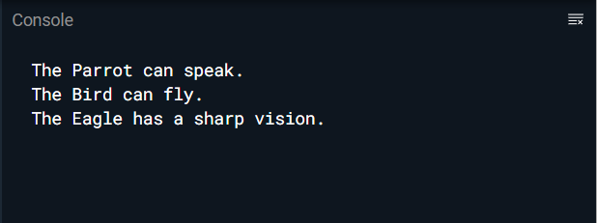

Q.2) Write a dart program to show Hierarchical Inheritance.

**CODE :**

class Person {

void dispName(String name){

print(name);

}

void dispAge(int age) {

print(age);

}

}

class Peter extends Person {

void dispBranch(String nationality) {

print(nationality);

}

}

//Derived class created from another derived class.

class James extends Person {

void result(String result){

print(result);

}

}

void main() {

// Creating Object of James class

James j = new James();

j.dispName("James :");

j.dispAge(24);

j.result("Passed");

// Creating Object of Peter class

Peter p = new Peter();

p.dispName("Peter :");

p.dispAge(21);

p.dispBranch("Computer Science");

}

**OUTPUT :**



Q.3) Write a dart program to implement Abstract class.

**CODE :**

abstract class Person {

void displayInfo();

}

class Boy extends Person {

void displayInfo(){

print("My name is Jonathon.");

}

}

class Girl extends Person {

void displayInfo(){

print("My name is Grecia.");

}

}

void main(){

Boy b = new Boy();

Girl g = new Girl();

b.displayInfo();

g.displayInfo();

}

**OUTPUT :**

